**4.2 Big-O Notation Worksheet** (submit for satisfactory outcomes)

1. Prove Prim’s Algorithm using the Loop Invariant technique.

Loop invariant: At the start of each iteration, the tree generated by Prim’s is a subgraph of the MST

Initialisation: Before the loop starts, the tree contains only the starting vertex, which must be part of the MST because by definition an MST contains all vertices

Maintenance: At the end of each iteration, Prim’s adds the shortest edge between the nodes currently in the tree and those not. The edge added must be part of the MST because choosing any other node will increase the cost, and therefore the edge chosen maintains a subgraph of the MST.

Termination: The loop terminates when all vertices have been included. According to the loop invariant, the graph is now a subgraph of the MST with all nodes, which is equivalent to the MST.

Hence, Prim’s always produces a correct output.

1. Consider the following Edgy code, and decide which time complexity $\{(O(1)$, $O(logn)$, $O(n)$, $O\left(nlogn\right),$ $O\left(n^{2}\right),$ $O\left(n^{3}\right), O(2^{n})$ $,O(n!)\}$ would best fit each example giving reasons for your conclusion. Also, write down a 1 or 2 sentence description for each mystery block stating what it does (without executing the code). Code and confirm*.*

**Example A: mystery2 block**

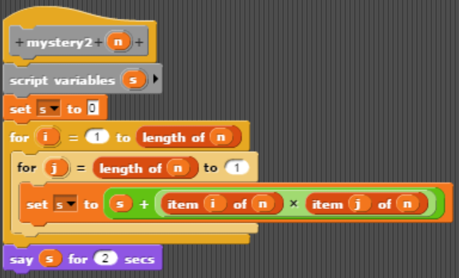

$O\left(n^{2}\right)$, it multiplies all the numbers of an array with their opposite pairs and then outputs the sum

**Example B:**

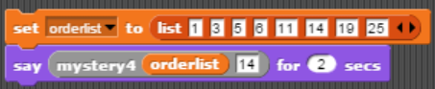

$O(1)$, it reads out the value of index 14 of the list.

